

**Number system converter and summer**

Made by: Abd-El Rahman Wael Sec.:2 B.N: 55

Mohamed Ashraf Sec.:3 B.N: 37



**Splash screen code**

Public NotInheritable Class SplashScreen2

Private Sub SplashScreen2_Load(ByVal sender As Object, ByVal e As System.EventArgs) Handles Me.Load

Timer1.Start()

End Sub

Private Sub Timer1_Tick(sender As System.Object, e As System.EventArgs) Handles Timer1.Tick

Dialog1.Show()

Me.Close()

End Sub

End Class

**Dialogue box code**

Imports System.Windows.Forms

Public Class Dialog1

Private Sub OK_Button_Click(ByVal sender As System.Object, ByVal e As System.EventArgs) Handles Button1.Click

If (IsNumeric(TextBox3.Text) And TextBox3.Text <> "" And IsNumeric(TextBox4.Text) And TextBox4.Text <> "") Then

If ((Val(TextBox3.Text) = 2 And Val(TextBox4.Text) = 55) Or (Val(TextBox3.Text) And Val(TextBox4.Text))) Then

Form1.Show()

Me.Close()

Else

MessageBox.Show("Please enter Section or Bench Number Correctly")

End If

Else : MessageBox.Show("Please enter" & Check_inputs() & "as a number.")

End If

End Sub

Private Function Check_inputs() As String

Dim Wrong_inputs As String

If (Not (IsNumeric(TextBox3.Text)) Or TextBox3.Text = "") Then

Wrong_inputs = Wrong_inputs & " Section "

End If

If (Not (IsNumeric(TextBox4.Text)) Or TextBox4.Text = "") Then

Wrong_inputs = Wrong_inputs & " Bench Number "

End If

Return Wrong_inputs

End Function

End Class

**Form box code**

Public Class Form1

Private Sub Button2_Click_1(sender As System.Object, e As System.EventArgs) Handles Button2.Click

Me.Close()

End Sub

Private Sub Button1_Click(sender As System.Object, e As System.EventArgs) Handles Button1.Click

If Me.Panel1.Controls.Count > 0 Then

Me.Panel1.Controls.Item(0).Dispose()

End If

Dim a As New Converter

Me.Panel1.Controls.Add(a)

End Sub

Private Sub Button3_Click(sender As System.Object, e As System.EventArgs) Handles Button3.Click

If Me.Panel1.Controls.Count > 0 Then

Me.Panel1.Controls.Item(0).Dispose()

End If

Dim a As New Summer

Me.Panel1.Controls.Add(a)

End Sub

End Class

**User control 1 code (Converter)**

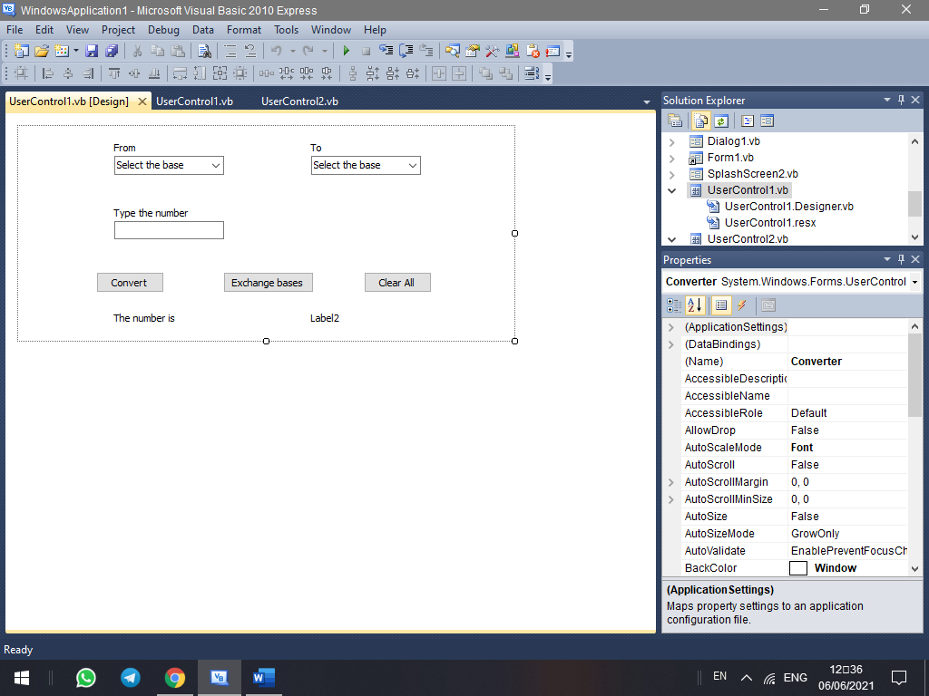

Imports System.Text.RegularExpressions

Public Class Converter

Private Sub Converter_Load(sender As System.Object, e As System.EventArgs) Handles MyBase.Load

Label3.Text = ""

Label6.Text = ""

End Sub

Private Sub Button3_Click(sender As System.Object, e As System.EventArgs) Handles Button3.Click

Dim Binarypattern As String = "[2-9]{1,}"

Dim Octalpattern As String = "[8-9]{1,}"

If (IsNumeric(TextBox1.Text) And TextBox1.Text <> "") Then

If (ComboBox1.Text <> "Select the base" And ComboBox2.Text <> "Select the base") Then

If ComboBox1.Text = "Decimal (Base 10)" Then

Dim data As Integer = CInt(TextBox1.Text)

If (ComboBox2.Text = "Binary (Base 2)") Then

Dim value = DecimalToBinary(data)

Label6.Text = value.ToString

ElseIf (ComboBox2.Text = "Octal (Base 8)") Then

Label6.Text = Oct(data)

ElseIf (ComboBox2.Text = "Decimal (Base 10)") Then

Label6.Text = data

End If

ElseIf ComboBox1.Text = "Binary (Base 2)" Then

Dim regex As Regex = New Regex(Binarypattern)

Dim match As Match = regex.Match(TextBox1.Text)

If match.Success Then

'here we test the range [01]

MessageBox.Show("Only digits from 0 to 1 are allowed")

Else : Dim data As Integer = Convert.ToInt32(TextBox1.Text, 2)

If (ComboBox2.Text = "Binary (Base 2)") Then

Dim value = DecimalToBinary(data)

Label6.Text = value.ToString

ElseIf (ComboBox2.Text = "Octal (Base 8)") Then

Label6.Text = Oct(data)

ElseIf (ComboBox2.Text = "Decimal (Base 10)") Then

Label6.Text = data

End If

End If

ElseIf ComboBox1.Text = "Octal (Base 8)" Then

Dim regex As Regex = New Regex(Octalpattern)

Dim match As Match = regex.Match(TextBox1.Text)

If match.Success Then

MessageBox.Show("Only digits from 0 to 7 are allowed")

Else 'here we test the range [0-7]

Dim data As Integer = Convert.ToInt32(TextBox1.Text, 8)

If (ComboBox2.Text = "Binary (Base 2)") Then

Dim value = DecimalToBinary(data)

Label6.Text = value.ToString

ElseIf (ComboBox2.Text = "Octal (Base 8)") Then

Label6.Text = Oct(data)

ElseIf (ComboBox2.Text = "Decimal (Base 10)") Then

Label6.Text = data

End If

End If

End If

Else : MessageBox.Show("Please select a base.")

End If

Else : MessageBox.Show("Please enter a number.")

End If

End Sub

Private Sub Button1_Click(sender As System.Object, e As System.EventArgs) Handles Button1.Click

ComboBox2.Text = "Select the base"

ComboBox1.Text = "Select the base"

TextBox1.Text = ""

Label6.Text = ""

TextBox1.Focus()

End Sub

Public Shared Function DecimalToBinary(dec As Integer) As String

If dec < 1 Then Return "0"

Dim binStr As String = String.Empty

While dec > 0

binStr = binStr.Insert(0, (dec Mod 2).ToString())

dec = Int(dec / 2)

End While

Return binStr

End Function

Private Sub Button2_Click(sender As System.Object, e As System.EventArgs) Handles Button2.Click

Dim A As String = ComboBox2.Text

ComboBox2.Text = ComboBox1.Text

ComboBox1.Text = A

TextBox1.Text = ""

Label6.Text = ""

TextBox1.Focus()

End Sub

End Class

**________________________________________________________**

**User control 2 code (Summer)**

Imports System.Text.RegularExpressions

Public Class Summer

Private Sub Summer_Load(sender As System.Object, e As System.EventArgs) Handles MyBase.Load

Label3.Text = ""

Label6.Text = ""

Label8.Text = ""

Label2.Text = ""

Label7.Text = ""

Label9.Text = ""

End Sub

Private Sub Button3_Click(sender As System.Object, e As System.EventArgs) Handles Button3.Click

Dim Binarypattern As String = "[2-9]{1,}"

Dim Octalpattern As String = "[8-9]{1,}"

Dim Num1 As Integer = False

Dim Num2 As Integer = False

Dim bln1 As Boolean = False

Dim bln2 As Boolean = False

If ComboBox1.Text <> "Select the base" Then

If (IsNumeric(TextBox1.Text) And TextBox1.Text <> "") Then

'Number1

If ComboBox1.Text = "Decimal (Base 10)" Then

Dim data As Integer = CInt(TextBox1.Text)

Num1 = Val(TextBox1.Text)

bln1 = True

ElseIf ComboBox1.Text = "Binary (Base 2)" Then

'here we test the range [01]

Dim regex As Regex = New Regex(Binarypattern)

Dim match As Match = regex.Match(TextBox1.Text)

If match.Success Then

MessageBox.Show("Only digits from 0 to 1 are allowed")

TextBox1.Text = ""

TextBox1.Focus()

bln1 = False

Else 'here we convert to decimal

Num1 = Convert.ToInt32(TextBox1.Text, 2)

bln1 = True

End If

ElseIf ComboBox1.Text = "Octal (Base 8)" Then

'here we test the range [0-7]

Dim regex As Regex = New Regex(Octalpattern)

Dim match As Match = regex.Match(TextBox1.Text)

If match.Success Then

MessageBox.Show("Only digits from 0 to 7 are allowed")

TextBox1.Text = ""

TextBox1.Focus()

bln1 = False

Else 'here we convert to decimal

Num1 = Convert.ToInt32(TextBox2.Text, 8)

bln1 = True

End If

End If

Else : MessageBox.Show("Please enter digits only for the first number.")

End If

Else : MessageBox.Show("Please select a base for the first number.")

End If

If ComboBox2.Text <> "Select the base" Then

'Number2

If (IsNumeric(TextBox2.Text) And TextBox2.Text <> "") Then

If ComboBox2.Text = "Decimal (Base 10)" Then

Dim data As Integer = CInt(TextBox2.Text)

Num2 = Val(TextBox2.Text)

bln2 = True

ElseIf ComboBox2.Text = "Binary (Base 2)" Then

'here we test the range [01]

Dim data As Integer = CInt(TextBox2.Text)

Dim regex As Regex = New Regex(Binarypattern)

Dim match As Match = regex.Match(TextBox2.Text)

If match.Success Then

MessageBox.Show("Only digits from 0 to 1 are allowed")

TextBox2.Text = ""

TextBox2.Focus()

bln2 = False

Else 'here we convert to decimal

Num2 = Convert.ToInt32(TextBox2.Text, 2)

bln2 = True

End If

ElseIf ComboBox2.Text = "Octal (Base 8)" Then

'here we test the range [0-7]

Dim data As Integer = CInt(TextBox2.Text)

Dim regex As Regex = New Regex(Octalpattern)

Dim match As Match = regex.Match(TextBox1.Text)

If match.Success Then

MessageBox.Show("Only digits from 0 to 7 are allowed")

TextBox2.Text = ""

TextBox2.Focus()

bln2 = False

Else 'here we convert to decimal

Num2 = Convert.ToInt32(TextBox2.Text, 8)

bln2 = True

End If

End If

Else : MessageBox.Show("Please enter digits only for the second number.")

End If

Else : MessageBox.Show("Please select a base for the second number.")

End If

'here we sum them

If (ComboBox3.Text <> "Select the base" And bln1 And bln2) Then

Dim decsum As Integer = Num1 + Num2

If ComboBox3.Text = "Decimal (Base 10)" Then

Label9.Text = decsum

ElseIf ComboBox3.Text = "Binary (Base 2)" Then

Label9.Text = Convert.ToString(decsum, 2)

ElseIf ComboBox3.Text = "Octal (Base 8)" Then

Label9.Text = Convert.ToString(decsum, 8)

End If

Label3.Text = "The sum is:"

Label6.Text = TextBox1.Text

Label2.Text = TextBox2.Text

Label8.Text = "+"

Label7.Text = "="

Else : MessageBox.Show("Please select a base for the summed number.")

End If

End Sub

Private Sub Button1_Click(sender As System.Object, e As System.EventArgs) Handles Button1.Click

ComboBox2.Text = "Select the base"

ComboBox1.Text = "Select the base"

ComboBox3.Text = "Select the base"

TextBox1.Text = ""

TextBox2.Text = ""

Label3.Text = ""

Label6.Text = ""

Label8.Text = ""

Label2.Text = ""

Label7.Text = ""

Label9.Text = ""

TextBox1.Focus()

End Sub

Public Shared Function DecimalToBinary(dec As Integer) As String

If dec < 1 Then Return "0"

Dim binStr As String = String.Empty

While dec > 0

binStr = binStr.Insert(0, (dec Mod 2).ToString())

dec = Int(dec / 2)

End While

Return binStr

End Function

Private Sub Button2_Click(sender As System.Object, e As System.EventArgs) Handles Button2.Click

Dim A As String = ComboBox2.Text

ComboBox2.Text = ComboBox1.Text

ComboBox1.Text = A

TextBox1.Text = ""

TextBox2.Text = ""

Label3.Text = ""

Label6.Text = ""

Label8.Text = ""

Label2.Text = ""

Label7.Text = ""

Label9.Text = ""

TextBox1.Focus()

End Sub

End Class

**________________________________________________________**

**The Program in operation**

|  |
| --- |
| **1** |
|  |
| **2** |
|  |
| **3** |
|  |
| **4** |
|  |
| **5** |
|  |
| **6** |
|  |